目录

1 Controller’s Problems 1

2 Add Viewer 1

3 link views to controller 4

# 1 Controller’s Problems

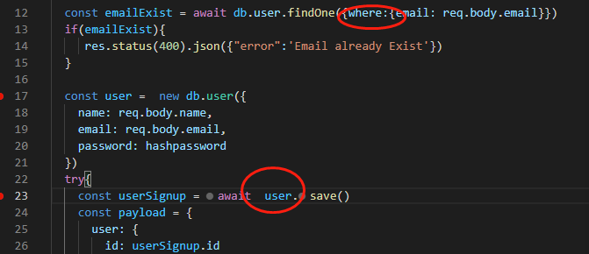

# 2 Add Viewer

1. Move css js to public folder, and change html to ejs and move them to the folder

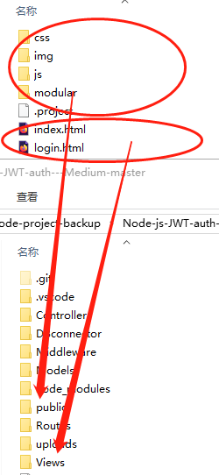

2 split html into parts

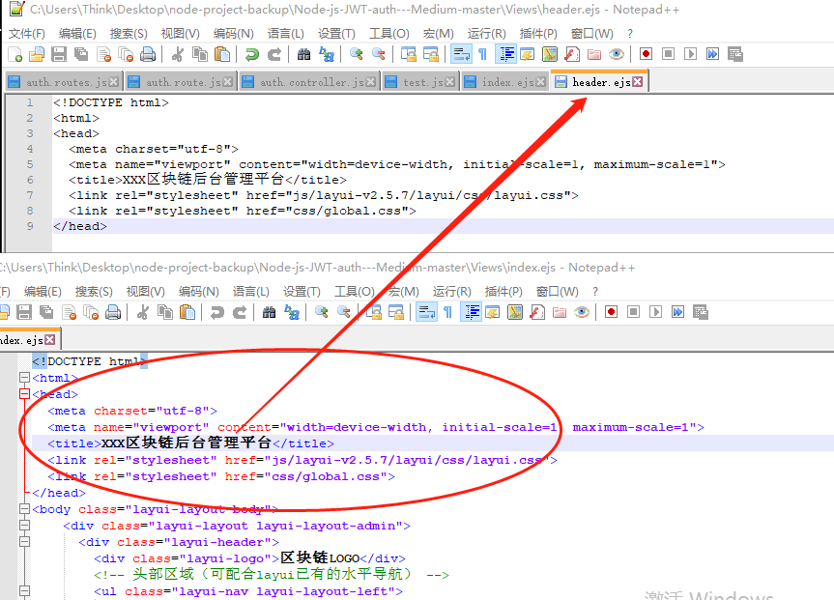

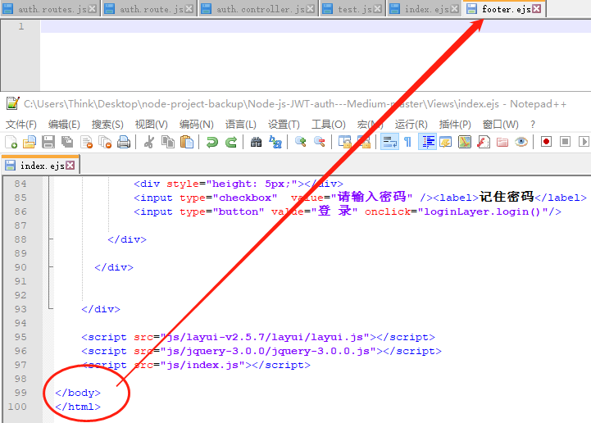

Eventually:

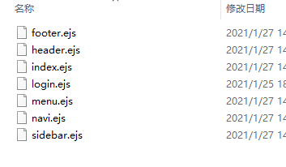

Index.ejs

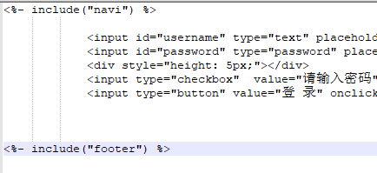

# 3 link views to controller

1. Add controller to apply_for

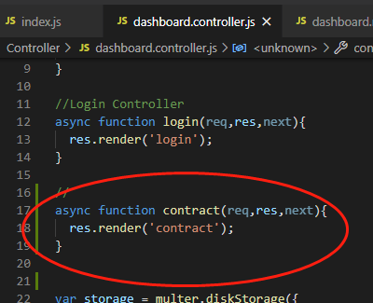

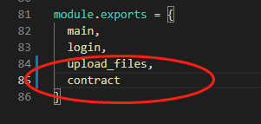

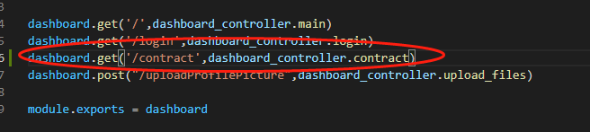

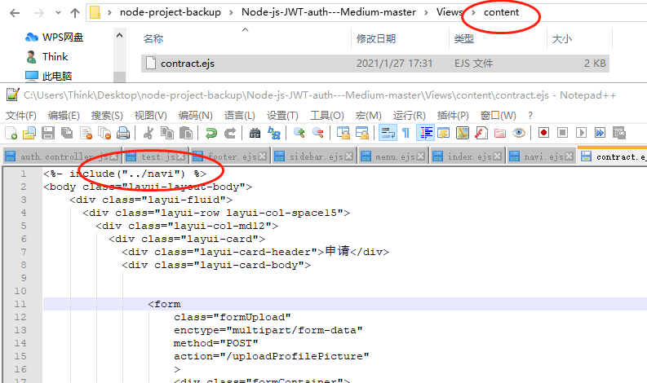

2 pass data from controller to the views

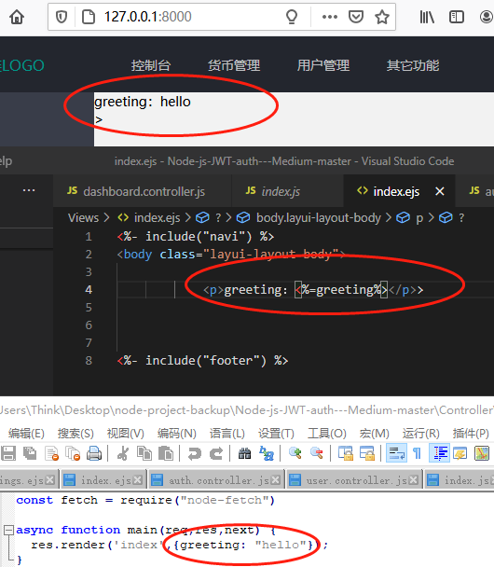

# 4 test form data from the login page

1 create a route to handle the form data, and create its corresponding controller

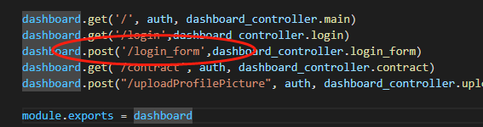

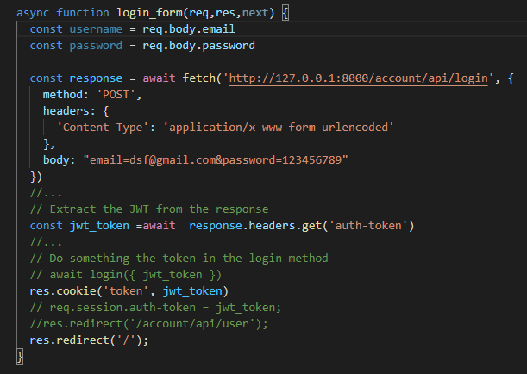

1. Create form

Set form data to www-form-urlencode, set names and set type to be submit, set action to be the route

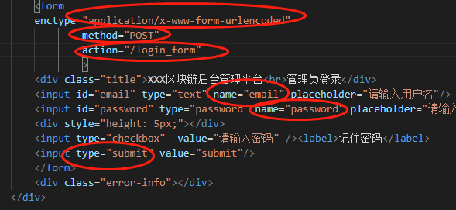

1. Test

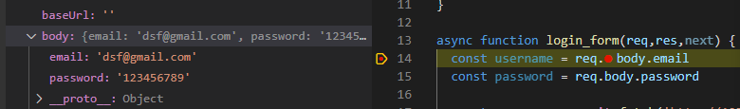

# 5 test JWT token with postman

1. Get token

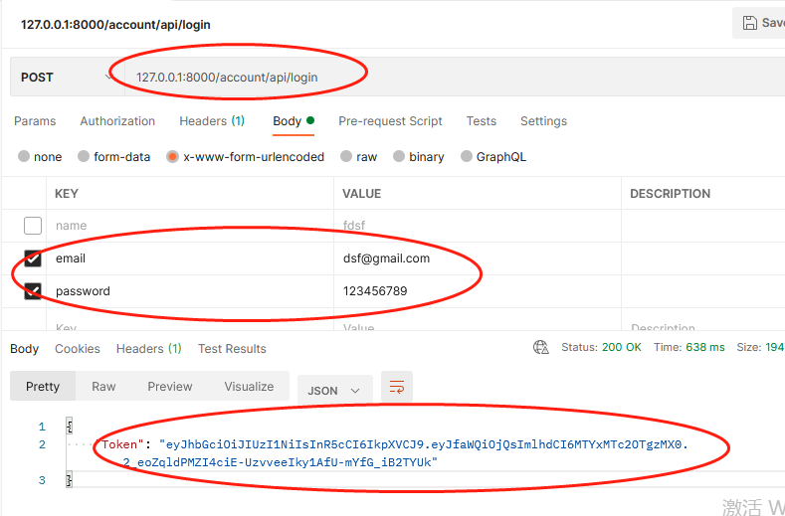

1. Add this token to get header

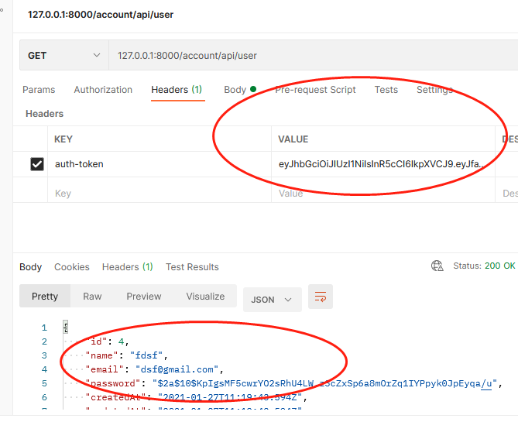

# 6 add auth to all routes except login page

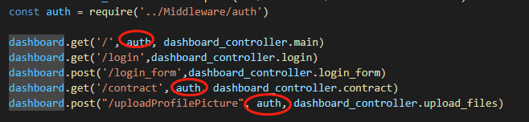

# 7 connect login frontpage with api

1 add login logic



2 use cookie to store token

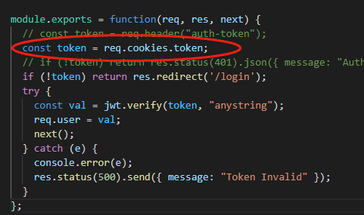

1. Test

It will return user info in json format on the browser

# add fileupload function: routes and controller

# Node upload to IPFS